Prime Numbers
Platform: HackerEarth
Language: C
Module 5, Question 5

Problem Link
https://www.hackerearth.com/problem/algorithm/prime-numbers/

Problem Statement
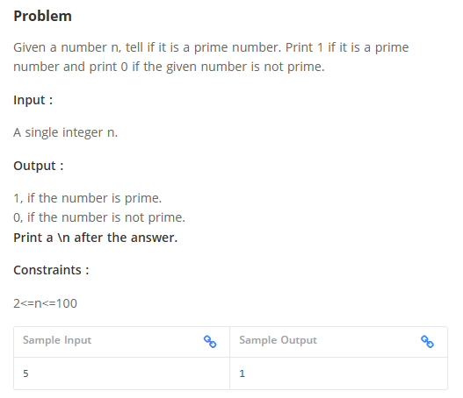

C Code
#include <stdio.h>

int isPrime(int n) {
if (n < 2) return 0;
for (int i = 2; i * i <= n; i++)
if (n % i == 0) return 0;
return 1;
}

int main() {
int n;
scanf("%d", &n);
printf("%d\n", isPrime(n)); // 1 if prime, 0 if not
return 0;
}

Screenshot of Successful Submission



